**Victorian**

**Public Transport Ticketing**

**Customer Guide**

Effective 1 January 2023

Table of contents

How to use this guide 3

Validity of tickets and customer obligations 5

Concessions and free travel 6

Concession fares 6

Free Travel Passes 10

Free Tram Zone 12

Free travel vouchers 13

Free travel days 15

Veteran Commemoration Days 15

Other Free Travel Days 16

Early Bird 16

Free Weekend travel 16

1 Day, 7 Day and 30 Day Travel Passes 17

myki 18

What is myki? 18

How to use myki 19

Where is myki valid? 20

Where to buy and top up a myki card? 20

How to buy a Mobile myki 23

How to top up a Mobile myki 23

Night Network 25

Automatic fare calculation 26

Non-myki V/Line 27

V/Line paper tickets 27

Where to buy V/Line tickets 28

Non-myki regional bus 29

Group and other travel 30

Free Primary School groups 30

Special event and conference ticketing 30

Accessible transport 31

Bicycles, animals and luggage 33

Bicycles 33

Travelling with your pet 36

Assistance Animals 38

# How to use this guide

# The Victorian Public Transport Ticketing Customer Guide complements the *Victorian Fares and Ticketing Conditions* (the Conditions). It is important that the two documents are read together as the Conditions set out the legally enforceable requirements and ticketing conditions for valid travel on Victoria’s public transport network. Non-compliance with the Conditions may result in a fine or legal action.

# This guide provides additional and supplementary information on ticketing, fares, concession, free travel and what can be taken on public transport services, with a greater focus on customer-friendly communications (such as images).

# If you need more information, you can:

# Contact PTV on **1800 800 007** 6am to midnight daily (all night Friday and Saturday); or

# Visit one of the following websites:

# ptv.vic.gov.au

# metrotrains.com.au

# Vline.com.au

# Yarratrams.com.au; or

# Visit a PTV hub:

# Southern Cross Station on the concourse near the corner of Spencer Street and Collins Street

# Application forms can be mailed to:

# PO Box 4724,

# Melbourne 3001.

# Geelong – Westfield Shopping Centre, 95 Malop Street, Geelong (ground floor near Target entrance)

# Bendigo – Bendigo Marketplace, 37 Garsed Street, Bendigo (near Bank of Melbourne); or

# Visit a staffed railway station.

# Contact a local bus operator.

# **Premium railway stations**

There are 83 Premium railway stations in metropolitan Melbourne that are staffed from first to last train, seven days a week. A list of Premium stations can be found on [PTV’s website](https://www.ptv.vic.gov.au/footer/customer-service/staffed-stations/).

Premium stations have a customer service centre, where you can top-up myki, buy V/Line tickets, see timetables, and get other information and change for vending machines.

Most [Premium](https://www.ptv.vic.gov.au/footer/customer-service/staffed-stations/) stations also have customer facilities like enclosed waiting areas and toilets.

# Validity of tickets and customer obligations

You must have a valid ticket to travel on public transport. Children aged 4 years and under travel free and do not need a myki.

The types of tickets available include:

* myki (card or Mobile myki)
* V/Line tickets
* Regional bus tickets
* Travel Passes
* Student Passes
* Free Passes; and
* other specific travel authorities.

Concession fares are available for eligible customers on all Victorian public transport services.

Combining myki and V/Line tickets

*Travel beyond the myki zone boundary*

If you are travelling beyond the myki boundary and normally use myki Money, you will need to purchase a V/Line ticket for the full trip, as there is no facility to touch on or touch off in a non-myki area.

If you are travelling beyond the myki zone boundary and have a myki Pass, you will need to purchase a V/Line ticket to cover the journey between the last station in a zone for which the myki Pass is valid and your destination station.

*Travel within the myki zone boundary*

If you have a myki Pass and want to travel beyond the zone/s covered by your pass, within the myki zone boundary, you can use myki Money for the additional zones, just top up your myki.

# Concessions and free travel

## Concession fares

Concession fares (50 per cent discount on the full fare) and free travel are available for people who meet the eligibility criteria. Details of eligibility requirements are listed in the *Victorian Fares and Ticketing Conditions*. If you need an application form for a concession, these are available from:

* ptv.vic.gov.au.
* PTV call centre on **1800 800 007**; and
* PTV Hubs.

Application forms may be submitted by post to PO Box 4724, Melbourne 3001.

***Table 1 - Summary of concession benefits***

|  |  |  |  |  |
| --- | --- | --- | --- | --- |
| Concession Category | 50% Fare Discount[1] | Free Travel Voucher Access | Free Weekend Travel[2] | Free Travel Days |
| Asylum Seekers | ✓ |  |  |  |
| Carers | ✓ | ✓ | ✓ | Yes – during Victorian Carers week |
| Child | ✓ |  |  |  |
| Disability Support Pension (DSP) | ✓ | ✓ | ✓ |  |
| Health Care Card | ✓ |  |  |  |
| Interstate Seniors | ✓ |  |  |  |
| International Tertiary Students (iUSE pass) | ✓[3] |  |  |  |
| Pensioners | ✓ | ✓ |  |  |
| School Students (primary or secondary) | ✓ |  |  |  |
| Tertiary Students | ✓ |  |  |  |
| Victorian Seniors | ✓ | ✓ | ✓ | Yes – during Victorian Seniors Festival |
| War Veterans and War Widow(er)s | ✓ | ✓[4] |  | Yes – during Veterans’ Health Week and commemoration days |

**Asylum Seekers (myki code A)**

Application forms may also be available from asylum seeker support providers. The application must be signed by an asylum seeker support organisation and include a passport-like colour photo.

If approved, applicants will receive a PTV Asylum Seeker ID which is valid for two years from the date of processing. It entitles the holder to travel with, and purchase and use, an Asylum Seeker concession myki, which can be purchased for $3.

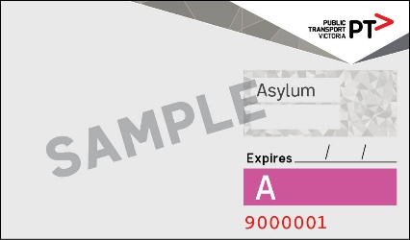

**Carer Card (myki code CAR)**

A Carer Card concession myki can be used if the customer holds one of the following cards and entitles the holder to concession fares, free weekend travel in two consecutive zones, and the option to register for free annual travel vouchers. Paper or digital cards are accepted as proof of concession entitlement.

Image result for We Care Carer Card OR 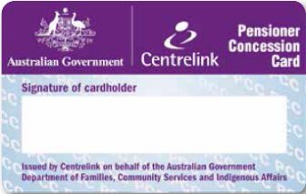 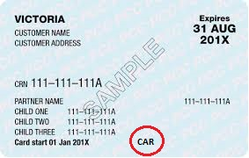

For more information on the Carer Card, contact the Carer Card Information Line on   
**1800 901 958**.

**Child (myki code C)**

Children aged 4 and under travel free and don’t need a myki.

Children aged between 5 and 18 can travel on a Child myki to access concession fares.

Customers aged 17 and 18 must carry additional proof of age, which can be one of the following:

* Driver licence
* Learner permit
* Proof of Age Card
* Passport
* Key Pass (issued by Australia Post)
* Health Care Card (with Victorian address)
* PTV School Student ID (issued by PTV)
* PTV Approved School Student ID (school ID card with the PTV logo)

**Disability Support Pension (myki code DSP)**

If you have a Centrelink Disability Support Pension card with a Victorian address, you are eligible for concession fares and free weekend travel in two consecutive zones and can register to receive free travel vouchers. Either paper or digital cards are accepted as proof of concession entitlement.

Spouses and dependents are not eligible for concession but may be eligible under another concession category – like a Carer Card myki.

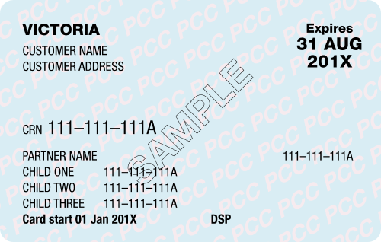

**Health Care Card (myki code HCC)**

Customers that hold a Centrelink Health Care Card with a Victorian address are eligible for concession fares. Paper or digital cards are accepted as proof concession entitlement.

Spouses and dependents are not eligible for this concession but may be eligible under another concession category.

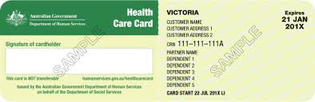

Confirmation of Concession Card Entitlement Vouchers can be used as proof of entitlement to this concession while a Health Care Card application is being processed.

**Interstate Seniors (myki code GC)**

All interstate Seniors Card holders are eligible for concession fares and can travel on a general concession myki in Victoria (interstate Seniors aren't eligible for a Seniors myki).

International Seniors, Commonwealth Seniors Health Care Card holders and National Seniors card holders are not eligible for concession fares.

✗

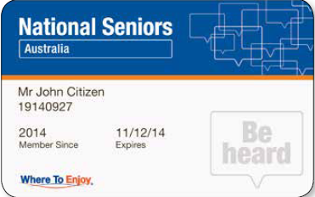

**International students – International Student Travel Pass**

The International Student Travel Pass offers eligible international undergraduate tertiary students a 365-day myki Pass at a 50 per cent discount on the full fare pass price. The International Student Travel Pass is loaded onto a personalised full fare myki Card which includes the cardholder’s photo.

International students should contact their tertiary institution to check their eligibility and obtain more details on how to purchase an International Student Travel Pass.

Tertiary education institutions can opt-in to the International Student Travel Pass scheme through PTV and should contact internationalstudent@ptv.vic.gov.au for more details.

**Pensioner Concession Card (myki code PCC)**

If you hold a Centrelink Pensioner Concession Card with a Victorian address, you are eligible for concession fares (myki code PCC) and can register to receive free travel vouchers.

Interstate Pensioner Concession Card holders can also access concession fares on a concession myki (code GC).

Either paper or digital cards are accepted as proof of concession entitlement. Partners and dependents are not eligible for this concession but may be eligible under another concession category.

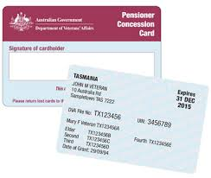

Confirmation of Concession Card Entitlement Vouchers can be used as proof of entitlement to this concession while a Pensioner Concession Card application is being processed.

**Primary or Secondary school student (myki code S)**

Primary or secondary school students can travel on a child myki until they are 19.

To use a primary or secondary school student myki, 17- and 18-year-olds must carry identification to either prove their age or verify they are attending a secondary school.

**Tertiary students (myki code T or T ½)**

Eligible tertiary students can travel on concession fares by applying for a PTV Tertiary Student ID card.

PTV Tertiary Student ID application forms can be processed at staffed railway stations and at PTV Hubs.

|  |  |
| --- | --- |
| **PTV Tertiary Student ID**  **Full Year**  Image result for full year PTV tertiary student ID | **PTV Tertiary Student ID**  **Half Year**  Image result for half year PTV tertiary student ID |

**Victorian Seniors (myki code VS)**

Victorian Seniors card holders are eligible for concession fares, as well as other benefits including free weekend travel in any two consecutive zones and on regional town buses, free travel during the annual Victorian Seniors Festival, and access to free travel vouchers.

Victorian Seniors applying for a Seniors Card will receive their first Seniors myki free. Any subsequent Seniors myki required will need to be purchased.

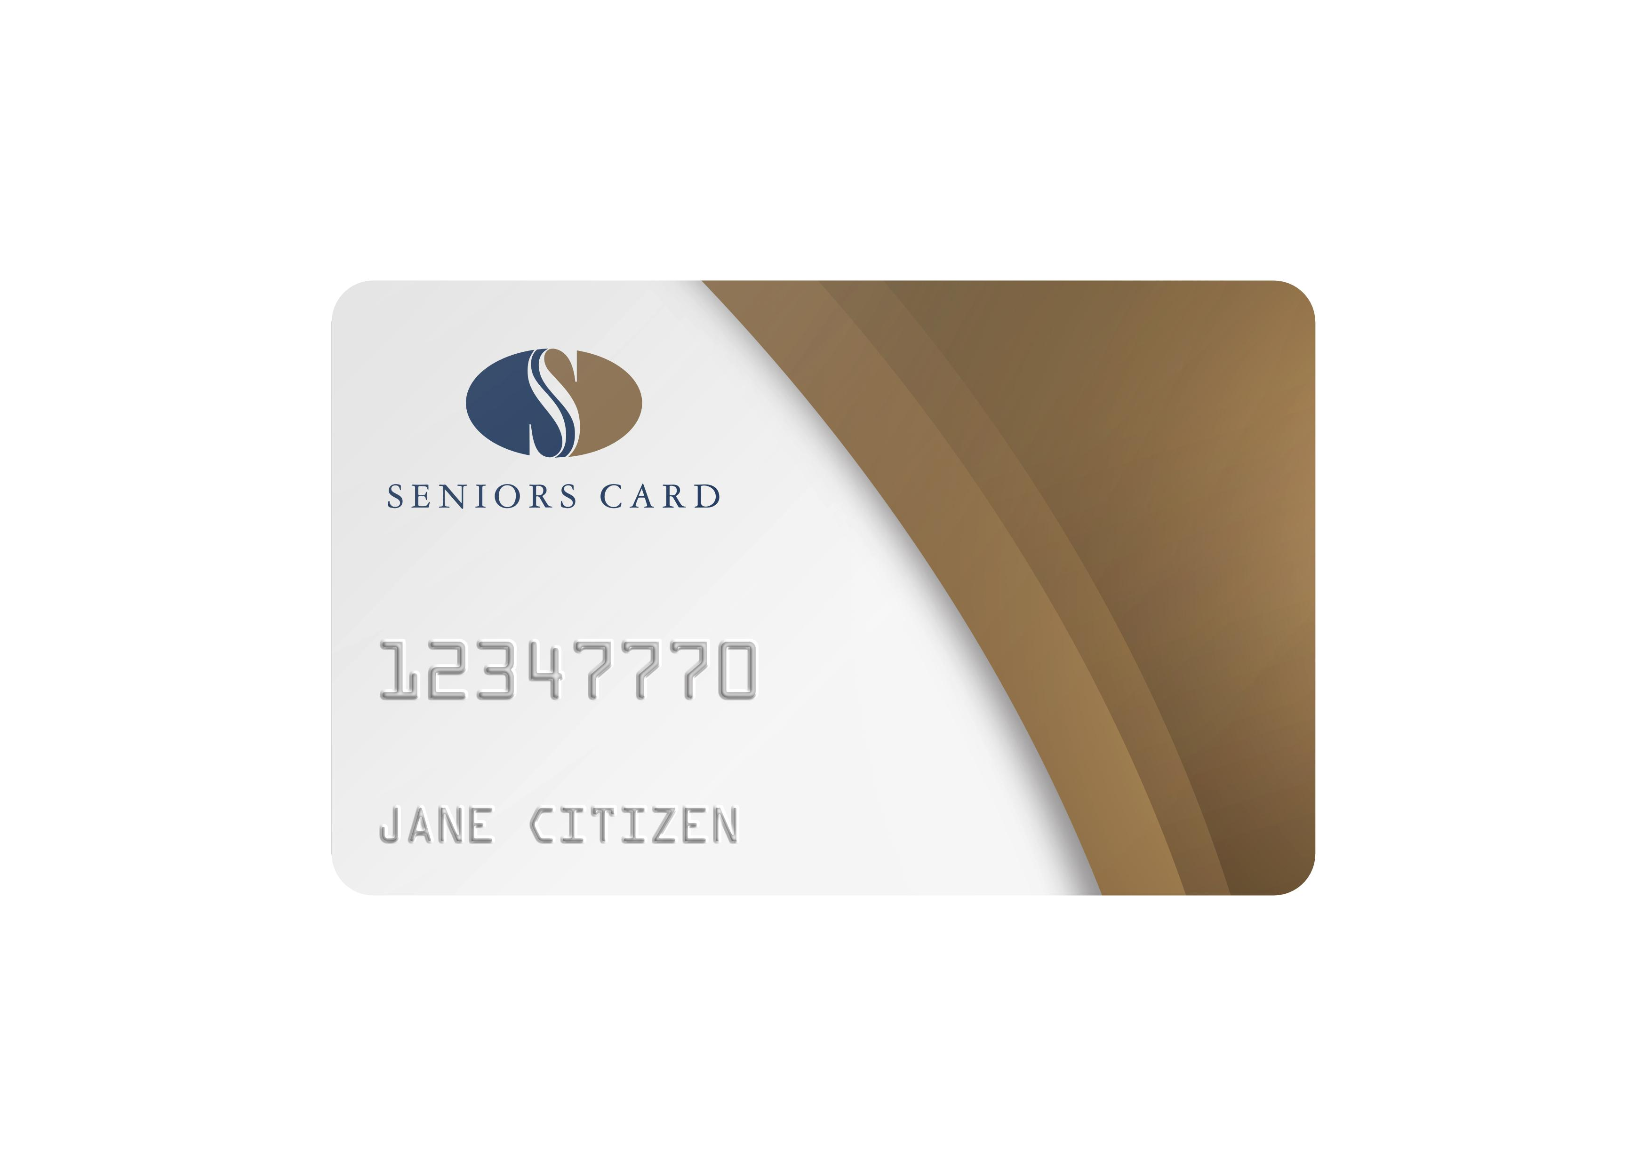 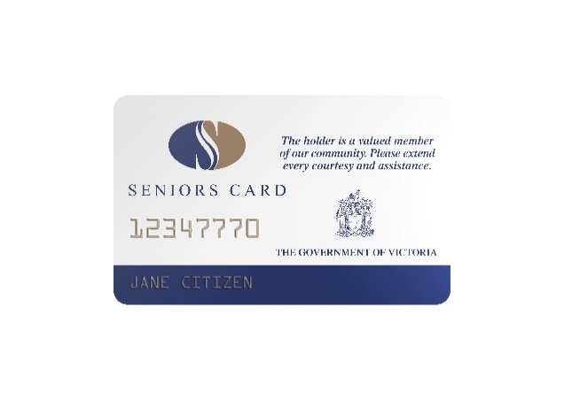

Interstate Seniors are not eligible for a Seniors myki but can purchase and travel on a general concession myki (myki code GC).

Seniors Business Card, National Seniors Card, Commonwealth Seniors Health Care Card and overseas Seniors Card holders are not eligible for a Seniors myki or concession travel. You may be eligible under another concession category. If not, you will need to pay full fare. 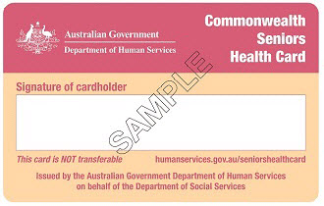  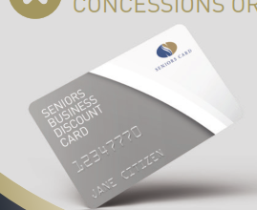

✗

✗

**War Veterans and War widows(ers) (myki code V)**

Veterans who have participated in overseas war or peacekeeping activities, as well as their widow(er), are eligible for concession fares. Department of Veterans’ Affairs Pensioner Concession Card holders can also access free annual travel vouchers.

This concession is only available if you are not eligible for concession under any other category.

## Free Travel Passes

The Victorian Government provides Free Travel Passes to some public transport customers who meet specific criteria. Free Travel Passes are loaded onto a myki card. Your myki card will look like a full fare card but will also have your name and photo on it.

Only the owner of a personalised myki card with a Free Travel Pass can use the pass for travel or to enter a compulsory ticket area.

Application forms are available from:

• ptv.vic.gov.au

• PTV call centre on 1800 800 007, and

• PTV Hubs

Completed forms can be submitted via mail to PO Box 4724, Melbourne 3001.

Free Travel Passes can’t be loaded onto a Mobile myki.

Customers should check if their Free Travel Pass is accepted before travelling with an interstate or private operator. These include NSW TrainLink, Great Southern Railway, airport services, tourist railways, privately run bus services and chartered trains, trams and buses.

In order to travel on a V/Line service for which a reservation is required, the free travel pass customer should phone **1800 800 007** to reserve a seat before travel.

**Access Free Travel Pass**

You may be eligible for an Access Travel Pass if you have a permanent physical disability, cognitive condition or mental illness that prevents you from using myki.

Customers using an Access Travel Pass are not required to touch on and touch off, but you are encouraged to if you can.

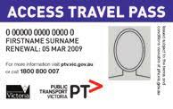

**EDA/TPI Ex-Service Personnel Free Travel Pass**

Victorian residents who hold a Department of Veterans’ Affairs (DVA) Gold Card embossed with EDA or TPI can apply for this Free Travel Pass.

**Scooter and Wheelchair Free Travel Pass**

If you depend on a scooter or wheelchair for mobility outside the home, you may be eligible for a Scooter and Wheelchair Free Travel Pass.

If you are using a Scooter and Wheelchair Travel Pass you don’t need to touch on and touch off, but you are encouraged to if you can.

**Travel Trainer Free Travel Pass**

This pass is for not-for-profit organisations that provide and deliver travel-training to people with a disability, enabling them to travel independently on public transport.

**Vision Impaired Free Travel Pass**

This pass is for those who are legally blind. Interstate Vision Impaired cards are accepted in Victoria.

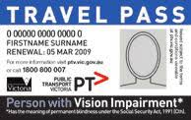

**War Veterans Free Travel Pass**

War Veterans who have served overseas, either in war or peacekeeping, and who meet the criteria can apply for this Free Travel Pass.

**Widow of WWI Veterans Free Travel Pass**

War widows of World War I veterans who have ‘War Widow’ embossed on their DVA Gold Card and meet the criteria can apply for a Free Travel Pass.

If you think you may be eligible for one of the above Free Travel Passes, submit your application to the PTV Hub at Southern Cross Station.

## Free Tram Zone

You do not need to touch on or off when travelling entirely within the Free Tram Zone. However, if your travel takes you outside the Free Tram Zone, you must touch on.

If you touch on while travelling entirely in the Free Tram Zone, no refund is available.

## Companion Card

If you require the support of a companion or carer when traveling and hold a Companion Card, your companion is eligible to receive free travel on Victoria’s metropolitan and regional public transport network.

The Companion Card holder will need to pay the appropriate fare; only the carer/companion of the card holder is eligible for free travel. If the Companion Card holder has a concession entitlement, they can use concession fares.

The carer and Companion Card holder must travel together. The carer must provide all necessary assistance to the Companion Card holder (including personal hygiene tasks). If carers are not able to assist, they will need to pay the appropriate fare for the journey.

When using V/Line services, Companion Card holders must ask for a Companion Ticket when buying or reserving their own ticket and show their Companion Card.

Interstate issued Companion Cards are accepted in Victoria. For more information, contact Victorian Companion Card Information Line on **1800 650 611** or visit [www.companioncard.org.au](http://www.companioncard.org.au).

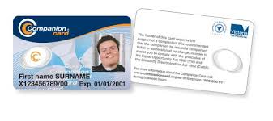

If you are a Companion Card holder and need additional carers to assist you to travel on public transport, you may be eligible for your additional carers to receive free travel. You can apply to get an additional companion sticker – the application form is available on the [PTV website](https://www.ptv.vic.gov.au/tickets/myki/concessions-and-free-travel/companion-card/). If approved, you will get a sticker that must be placed on your Companion Card to indicate to transport staff that your carers may travel free on public transport.

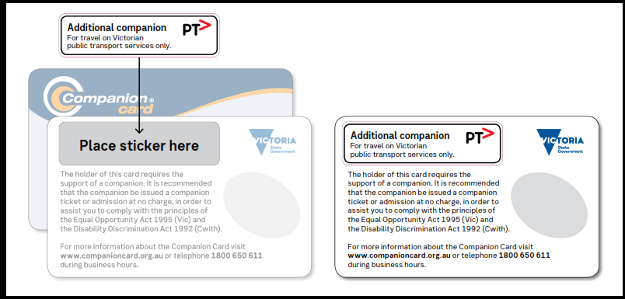

## Free travel vouchers

Annually, you’re eligible for 2 x (Melbourne metropolitan customers) or 4 x (regional customers) free travel vouchers if you live in Victoria and hold a:

* Pensioner Concession Card (PCC) (all codes) or
* Department of Veterans’ Affairs (DVA) PCC or
* Victorian Seniors Card or
* Victorian Carer Card (‘We Care’ Card).

Please note that the number of vouchers allocated is based on the postcode of your registered postal address. Geographic classification is determined by PTV.

New customers will need to register to be eligible. Once registered, existing customers only need to register again if their details change.

You can register:

* [**ONLINE**](https://www.ptv.vic.gov.au/tickets/myki/concessions-and-free-travel/free-travel-vouchers/free-travel-vouchers-registration-form/)
* In person at a [PTV Hub](https://www.ptv.vic.gov.au/footer/customer-service/ptv-hubs/) - you'll need to bring your proof of eligibility card with you.
* By calling us on [1800 800 007](https://www.ptv.vic.gov.au/footer/customer-service/public-transport-call-centre/).

PTV has a twice-yearly intake of registrations:

* Register between 1 March and 31 August and your voucher allocation will be available to access from 1 November
* Register between 1 September and 28 February and your voucher allocation will be available to access from 1 May.

If you're unsure if you have registered or want to check how many vouchers you have used or have left, you can check your registration status and voucher usage [here](https://www.vline.com.au/free-travel-vouchers).

If your details change after you have registered, you'll need to let us know by [re-registering online](https://www.ptv.vic.gov.au/tickets/myki/concessions-and-free-travel/free-travel-vouchers/free-travel-vouchers-registration-form/) with your new details or by calling 1800 800 007.

Registered customers will be available to use their next round of vouchers by simply

* visiting a staffed station or booking agent (at least 30 minutes prior to travel); or
* calling the PTV Call Centre (allow 10 business days for postage or collect your ticket from a station or agent 30 minutes prior to travel).

Customers will need to tell the staff member their concession card number and our staff can book your travel and record your voucher usage. Our staff can also tell customers how many vouchers are left at any time.

The voucher allocation will automatically refresh on 1 November each year and are valid for 12 months (until 31 October the following year).

Free Travel Vouchers must be redeemed and used for travel before the expiry date. The free travel vouchers can be exchanged for the following types of tickets:

* a Zone 1+2 Daily V/Line ticket (for use in metro areas – can be exchanged at metropolitan premium stations and PTV Hubs) or;
* an Off-peak Economy class V/Line Daily paper ticket (see below for conditions);
* two Off-peak Economy class V/Line single paper tickets (to return on a different day)

Voucher conditions:

* Travel must be off peak
* Travel must be wholly within Victoria - not part of an interstate journey (an exception for travel to Albury, Mount Gambier and Deniliquin)
* Not valid for tickets issued by interstate operators (NSW Trainlink / Great Southern Rail). However, they are valid for V/Line issued tickets on Great Southern Rail
* V/Line - must be continuous journey from A to B with no break in between (as per JP advice)
* Only one voucher can be used for one passenger
* Vouchers cannot be given to a third party for their use
* Someone can redeem your voucher on your behalf, if the voucher is signed and accompanied by the signed entitlement card (e.g., Seniors Card or Health Care Card). Note: only the voucher recipient can use the redeemed ticket for travel

Not valid for the following locations

* Tocumwal - Griffith
* Speedlink (Albury to Adelaide)
* Canberra link (Albury to Canberra)
* Sapphire Coast Link (beyond Genoa)
* Capital Link (beyond Cann River)
* Mansfield to Mt Buller

## 

## Free travel days

The Victorian Government offers free state-wide travel on all public transport services to eligible concession customers during:

* Seniors’ Festival Week
* Veterans’ Health Week and commemoration days; and
* Carers’ Week.

Eligible customers using a myki must touch on and off, but no fare will be charged.

For free travel on non-myki regional bus services, eligible customers must show or carry the relevant proof of eligibility (set out below).

## Veteran Commemoration Days

**ANZAC Day**

Free travel is available for veterans and armed forces personnel who need to travel the day before and after ANZAC Day to attend commemorations, as well as on ANZAC Day (so three days in total). To access free travel on these days, carry or wear (as applicable) one of the following forms of identification—

* DVA Gold or White Card
* War Veterans/War Widow(er)s myki card (Code V)
* An armed forces uniform
* Service medals
* Returned from active service badge
* War widow’s badge; or
* Ex-services association badge.

Eligible ANZAC Day Paradeparticipants can also travel free on ANZAC Day (see eligibility criteria below).

**Vietnam Veterans’ Day**

On Vietnam Veterans’ Day, Veterans and War Widows(er)s wearing or carrying one of the forms of identification listed for ‘ANZAC Day’ and eligible Vietnam Veterans’ Day parade participants (see eligibility criteria below) can travel free.

**Veterans’ Health Week**

During Veterans’ Health Week, Veterans and War Widows(er)s carrying a DVA Gold or White Card or War Veterans/War Widows(er)s myki card can travel free.

**Remembrance Day**

On Remembrance Day (11 November) Veterans and War Widows, wearing or carrying one of the forms of identification listed for ‘ANZAC Day’, are eligible for free travel, along with Remembrance Day parade participants (see criteria eligible parade participants below).

**Eligible Parade Participants (for ANZAC Day, Vietnam Veterans’ Day and Remembrance Day parades):**

* persons wearing an armed forces uniform
* band members in uniform
* school students in uniform; or
* Girl Guides and Scouts in uniform.

## Other Free Travel Days

**AFL Grand Final**

From the Wednesday before the AFL Grand Final to the Saturday of the AFL Grand Final (inclusive) the Free Tram Zone will be extended to the Melbourne Cricket Ground (MCG). The additional stops included in the Extended Free Tram Zone are as follows:

| **Tram route** | **Extended Free Tram Zone stops** |
| --- | --- |
| 48 and 75 | Stop 9 (Lansdowne Street), Stop 10 (Jolimont Road), Stop 11 (Jolimont Station/MCG) |
| 70 | Stop 7a (William Barak Bridge), Stop 7b (Rod Laver Arena) and Stop 7c (MCG/Melbourne Arena) |

For tram trips that are wholly within the Extended Free Tram Zone, you don’t need a ticket. You don’t need to touch on or touch off in the Free Tram Zone, however if you do, you will be charged a fare, which is not refundable.

**Christmas Day**

Travel on public transport is free on 25 December from the first to the last service.

**New Year’s Eve**

Travel on public transport is free from 6.00 pm on 31 December to 6 am on 1 January each year.

## Early Bird

If you travel on **metropolitan train services** and touch on and off within 2 hours and before 7.15am on a weekday, you will receive **free** travel for the trip.

To allow sufficient time to disembark and reach a myki reader to touch off, it is recommended that customers seek services with a 7.00am arrival time. No refunds or reimbursements are provided if you miss the cut-off time for early bird travel. Your journey won’t be free if your myki balance is negative.

**Please note:** V/Line train services are not eligible for the Early Bird fare, except for travel between Pakenham or Sunbury and Melbourne.

## Free Weekend travel

If you have one of the following myki concession cards, you’re entitled to free weekend travel in two consecutives zones.

* Seniors
* Disability Support Pensioner Concession Card (Code DSP)
* Carer Payment recipient Pensioner Concession Card (Code CAR)
* Carer Card

If you’re travelling on a non-myki town bus, you can show your entitlement as a flash pass to receive your free travel. Free travel does not apply to intertown buses.

See the *Victorian Fares and Ticketing Conditions* for more detailed information on free weekend travel.

## 1 Day, 7 Day and 30-Day Travel Passes

Only authorised community service organisations or charities can issue Travel Passes to their clients. They are not available for purchase at a retail outlet or by the public.

Customers can use their Travel Pass on all PTV contracted public transport services within Victoria including.

* bus, train, and tram trips in metropolitan Melbourne (Zone 1 and 2).
* all regional town buses.
* PTV inter-town buses.
* V/Line coaches; and
* V/Line trains.

The holder of a 1 Day, 7 Day or 30-Day Travel Pass must:

* Always carry the Travel Pass when traveling on public transport or entering a compulsory ticket area.
* show the Travel Pass to a barrier attendant when entering or leaving a compulsory ticket area through a staffed ticket barrier at a railway station
* show the travel pass to the driver on buses and coaches.

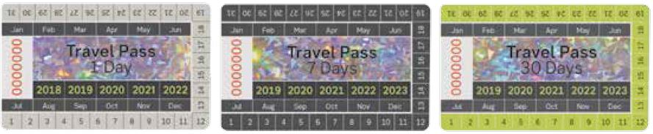

# myki

## What is myki?

myki is a reusable ticket used to pay for travel on metropolitan trains, trams and buses, V/Line myki commuter trains and myki-enabled regional buses.

There are two types of myki available:

* myki Smartcard is a reusable plastic smartcard; and
* Mobile myki is a reusable digital card available through a software application on an Android smartphone) (see required hardware and software requirements at [ptv.vic.gov.au/mobilemyki](https://vicgov.sharepoint.com/sites/VG000509/Documents/Fares%20&%20Ticketing/VFTM%20restructure%202/Customer%20guide/ptv.vic.gov.au/mobilemyki)).

A myki Smartcard is electronically encoded with a customer category which reflects fare eligibility and any other applicable benefits (e.g., free weekend travel for certain concession categories). Only one category can be stored on a myki at any one time, and this is used by the system to calculate the correct fare.

A panel is provided on the charcoal-coloured myki Smartcard to allow the cardholder to write identifying information (e.g. the concession type or the name of the cardholder).

To be valid for travel, a myki must be successfully touched on in accordance with the Conditions, except journeys wholly within the free tram zone (no touch on or touch off is required).

To ensure the automatic calculation of the lowest fare for a trip, the customer must touch on and touch off their myki in accordance with the Conditions, otherwise a default fare may be charged.

It is the customer’s responsibility to maintain enough balance to cover all travel made. In the case of Mobile myki, it is the customer’s responsibility to ensure that their phone is sufficiently charged to touch on and off during the journey and present a valid ticket if requested.

myki Smartcard and Mobile myki can store both myki Money and myki Passes.

**myki Money**

With myki Money, customers need to top up their myki with money before travelling. The correct fare for any journey is automatically calculated after the customer has touched on and touched off on public transport.

Fares are calculated according to where and when the customer travels and are automatically deducted from the myki Money balance when the customer touches off. In addition, daily caps apply for travel. Unless the value of a top up is recorded on the myki, it does not form part of the card’s myki Money balance and cannot be used for travel.

**myki Pass**

A myki Pass is an authority to travel within a zone or range of zones for a specified number of consecutive days.

A myki Pass covers travel in the zone(s) for which it is valid, and myki Money may be used to pay for any travel outside of the zone(s) for which the myki Pass is valid.

A myki Pass can be purchased for 7 or between 28 and 365 consecutive days (some restrictions apply when purchasing a myki Pass for a Mobile myki via Google Wallet).

Unless a myki Pass is recorded on the myki, the Pass cannot be used for travel.

Customers still need to touch on and off for each trip in accordance with the Conditions.

It is recommended that customers do not purchase a myki Pass with an expiry date beyond the expiry date of their concession entitlement to avoid a potential fine.

To be valid for travel, a myki must be successfully touched on (indicated by the myki reader showing a green light) except for travel wholly within the free tram zone (no touch on or touch off is required).

**myki card - Full Fare, Concession and Free Travel Passes**

image of the back of a myki card which includes the card number and a box for the customer to write any identifying informationimage of the front of a myki card

Above is the standard myki card design for most customer categories.

Mobile myki shows an image of the standard charcoal myki card design.

## How to use myki

**Touch on/touch off**

Once a myki is purchased and topped up with myki Money or a myki Pass, to use the myki for travel, customers need to touch on to a myki reader at a railway station, on a bus or on a tram, and touch off.

When using myki Money, failure to touch off will result in a default fare being applied, which may be higher than the fare that would have been paid had touch off occurred. More information on default fares can be found in the Conditions.

For Mobile myki, the smartphone containing the Mobile myki is used to physically touch on and off when travelling. For Mobile myki to operate, the smartphone must be in an awake state.

Touch on

For a successful touch on (at any type of myki reader), a myki must have a myki Money balance of at least $0.00 (including if customers are using a myki Pass). If your myki Money balance is negative, gates won’t open (even if you’re using a myki Pass).

Touch off

Touching off allows myki to calculate your trip duration, calculate the fare and apply any discounts – such as off-peak discount on V/Line or Early Bird for metropolitan customers.

When touching a Mobile myki on or off with a smartphone, it is recommended that customers look at the myki reader for an indication of whether the action is successful.

Exceptions to when to touch on and off

**Tram** beyond the Free Tram Zone - touch on only

entirely within Free Tram Zone - no touch on or off

entirely within zone 2 - touch on and off

**Train** always touch on and off

**Bus** always touch on and off.

**Replacement buses** touch on and off (unless otherwise advised) – this may mean you need to go to the station to touch on and off

**Please note**: ‘All Door Boarding’ is being progressively introduced on buses operating within the myki network This will mean passengers can board and touch on at any door. Implementation began in early 2021 on a stop-by-stop basis across the bus network, and is expected to be completed in 2022,

## Where is myki valid?

The public transport services on which a myki can be used are:

* Metropolitan trains
* Trams
* All Melbourne metropolitan bus services
* V/Line (regional) myki commuter train services
* Regional bus services operating in:
  + Bacchus Marsh
  + Ballarat
  + Bellarine
  + Bendigo
  + Churchill
  + Geelong
  + Kilmore
  + Moe
  + Mornington Peninsula
  + Morwell
  + Seymour
  + Traralgon
  + Wallan
  + Warragul.

## Where to buy and top up a myki card

A full fare or Concession myki card is available to purchase and may be topped up at the following locations:

* staffed metropolitan railway stations
* staffed myki enabled V/Line railway stations
* 7-Eleven stores and other myki retailers (full fare, child, Seniors, and concession only)
* V/Line myki agents
* myki machines (full fare myki only available) at myki enabled railway stations, selected tram stops and bus interchanges
* online from [**ptv.vic.gov.au**](http://ptv.vic.gov.au/)
* by calling **1800 800 007**
* PTV Hubs.

Please note you cannot buy or top up a myki on board a tram or bus*.

*Like the tram network, all buses within the myki network are now ‘Prepay’ only, which means cash or EFTPOS is not accepted to purchase or top up myki cards onboard. Passengers need to ensure they have a valid myki with sufficient funds before they travel.

This includes Melbourne, Geelong, Ballarat, Bendigo, Latrobe Valley, and other bus services where myki is accepted.

No change is provided when topping up myki Money at a myki machine. Five cent coins are not accepted.

A myki Card must be topped up with at least $1 or a myki Pass at purchase (except for purchases made via the PTV Call Centre and website, where the minimum top up is $10).

Customers are strongly advised to purchase a myki from an authorised retailer to avoid the risk of fraud.

A maximum myki Money top up of $250 applies.

BPay top up is available through the customer’s bank account.

Even when purchased, myki cards remain the property of the Head, Transport for Victoria.

### Commuter Club

A Commuter Club scheme is available for employers or other organisations to purchase 365-day myki Passes on behalf of the organisation’s employees/members/volunteers at a discount rate of 10 per cent.

It is up to the organisation how they choose to offer employees a Commuter Club myki, for example, salary package, one-off payment etc. It is also at the discretion of the organisation whether they pass on all or part of the discount to their employees; for example, some organisations may choose to deduct a handling fee.

A Commuter Club card that is damaged and not working can be replaced at a staffed station.

To report a lost or stolen Commuter Club myki, contact PTV. A replacement card will be sent out within 10 business days.

Alternatively, you can visit a PTV Hub. A replacement card will be issued on the spot and balance transferred within 36 hours. You’re responsible for covering interim travel costs.

If you need to travel while you wait for your old balance to be transferred to your new card, top up with myki Money or use a myki Pass.

For more information on how the myki Commuter Club works or to register an organisation, email [commuterclub@ptv.vic.gov.au](mailto:commuterclub@ptv.vic.gov.au).

### Student Passes – myki

Student Passes are available for state-wide travel and travel in selected regional areas for half year and full year periods.

Student Passes can be purchased at any staffed railway station.

To get a Student Pass, you must have a PTV Approved School Student ID card or a PTV School Student ID card. You need to carry your Student Pass and ID when travelling.

For more information on Student Passes, visit the [PTV website](https://www.ptv.vic.gov.au/tickets/myki/concessions-and-free-travel/children-and-students/school-students/).

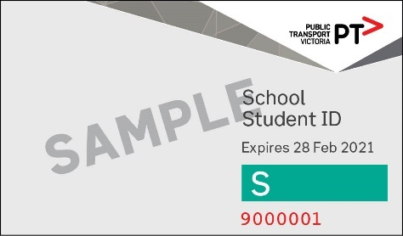

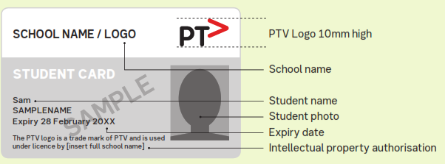

## Time taken to credit myki balance

**Instant top up**

When customers top up myki Money or load a myki Pass through a myki ticket machine (including Quick Top Up machines), ticket office (e.g., staffed station), PTV Hub, retailer (e.g., 7-Eleven) or another myki agent, the myki Money or Pass is recorded on the myki card immediately.

You can also top up your myki Money balance instantly using the PTV app on your mobile phone anytime, anywhere. This technology uses Near Field Communication (NFC) to allow people to top up their myki using their mobile phone.

**Website and call centre**

When customers top up myki Money or load a myki Pass onto a myki **online** (including through the PTV app) or through the PTV call centre, the amount to be topped up (or Pass to be loaded) is downloaded to myki equipment so it can be recorded on the customer’s myki when it is next presented to a myki machine or myki reader.

Customers are advised it may take up to 90 minutes for online and call centre top ups to process and be downloaded to equipment.

The myki Money or myki Pass will then be added to the customer’s myki (i.e., ‘collected’) when they next interact with a myki machine or reader (e.g. touch on, top up or check their balance etc.).

myki Money or myki Passes purchased online or via phone are available to be ‘collected’ for 30 days, after which time they are placed into dormancy. To reactivate the funds from dormancy, a myki must be:

* presented at a myki machine, ticket office, Quick Top Up machine or retailer (in this case, the funds or Pass will be reactivated and available on the myki card immediately)
* touched on (i.e., used for travel) at a myki reader (in this case, the dormant funds will take 24 hours to be reallocated to the myki, after which time it can then be ‘collected’ the next time the card interacts with a myki machine or reader).

Note: Existing balances are not affected by the dormancy process – just the top up amount (or Pass) purchased online or via phone.

**BPay**

Top ups made via BPay must first be processed by the customer’s bank and may take up to five days for the myki Money or myki Pass to be able to be recorded on the myki.

**Auto Top Up**

An Auto Top Up amount is credited to a customer’s myki immediately the first time a customer touches on or uses a myki machine after the myki Money balance falls to or below the specified threshold level.

## Mobile myki

Mobile myki offers Full Fare and Concession myki (Victorian Seniors, Child and Concession only) on Android smartphones only. A Mobile myki card can only be purchased and initially topped up through the Google Wallet smartphone application using a MasterCard or Visa credit or debit card.

There is no cost to buy a Mobile myki however it must be topped up with at least $10 of myki Money or a myki Pass at purchase.

If you use a concession Mobile myki, you will need to carry the correct proof of entitlement to concession fares with you, as specified in the Conditions.

In Google Wallet, a Mobile myki digital card is called a ‘ticket’.

After purchasing a Mobile myki, customers can choose to register their Mobile myki or leave it unregistered. Mobile myki can only be registered online at [ptv.vic.gov.au](http://ptv.vic.gov.au/).

### How to top up a Mobile myki

Mobile myki can only be topped up using Auto Top Up (see information below) or:

* through Google Wallet (including the Auto Load feature);
* by calling **1800 800 007**.
* via the [PTV website](http://www.ptv.vic.gov.au).

A customer can top up myki Money through the Google Wallet app with any amount from $10 to $50 (whole dollar amounts only).

Please note that the default top-up amount in Google Wallet is set to $10, but this can be changed by the customer.

Only myki Passes for 7, 28, 30, 31, 35, 40, 60 or 365 days are available for purchase through Google Wallet.

If you wish to purchase a myki Pass for a duration other than those available through Google Wallet, you can purchase a pass for duration between 28 and 365 days at [ptv.vic.gov.au](https://www.ptv.vic.gov.au/) or by calling PTV.

Please note that in Google Wallet a myki is called a ‘ticket’, and a myki Pass is called ‘X-Day ticket’, with X representing the number of days of the myki Pass.

When a customer tops up myki Money or loads a myki Pass via Google Wallet onto a Mobile myki, the myki Money or myki Pass is recorded on the Mobile myki generally within 10 minutes, subject to the availability of enough data connection for the software application on the smartphone.

### Auto Load

Mobile myki users have the option of topping up using Auto Load which is a feature of Google Wallet.

Customers using Auto Load and travelling in more than two zones (for example, on V/Line commuter train services) need to ensure they have enough myki Money to pay for the fare for their trip before travelling in order to have a valid ticket.

Auto Load is available for Mobile myki even if the Mobile myki is unregistered.

Customers are advised to update their Auto Load settings in the event their credit card or debit card details change.

### How to move a Mobile myki from one device to another

If a customer has a new personal electronic device and wishes to continue using their existing Mobile myki from their old device, they will need to—

1. deactivate their existing Mobile myki in Google Wallet on their old device; and
2. on the new device, set up their Google Wallet account using the same account information.

The customer will then be able to reactivate their existing Mobile myki on the new device.

## Auto Top Up

For maximum convenience, customers are encouraged to use Auto Top Up for myki Money.

Auto Top Up is available for registered myki only, providing extra convenience and security.

An Auto Top Up amount is credited to a customer’s myki immediately the first time a customer touches on or uses a myki top up machine after the myki Money balance falls to or below the specified threshold level.

Customers may set the Auto Top Up threshold between $10 and $250 to trigger a top up to ensure they always have sufficient myki money balance.

Customers using Auto Top Up and travelling in more than two zones (for example, on V/Line myki commuter train services) need to ensure they have enough myki Money to pay for the fare for their trip before travelling to have a valid ticket.

Customers are advised to update their Auto Top Up settings in the event their bank account or credit card details change.

## Checking your balance

For a myki Smartcard, the myki Money balance can be checked at any time at any 7-Eleven, other myki retailers, myki machines, myki checks, the PTV Hubs and staffed railway stations.

Customers can also check myki Money balances by calling PTV, online or via the PTV App.

The remaining balance of a myki may be displayed on some myki readers when a customer touches on or off. The myki card balance will display for as long as the myki card is held to the myki device.

For a Mobile myki, the myki Money balance can be checked through Google Wallet or at a myki check machine.

## Registered myki

Registering a myki with PTV is free and customers are required to supply some personal details during the registration process.

Registration is recommended for all myki customers, particularly customers who use myki Pass, so that the value on the myki is protected if it is lost or stolen.

PTV’s Privacy Policy can be viewed [here](http://www.ptv.vic.gov.au/footer/legal-and-policies/information-privacy-policy).

An account holder may manage multiple myki accounts and may manage a myki account on behalf of someone else. For example, a parent or guardian may manage a child’s myki account. This should be set up at the time of applying for a myki.

## Night Network

The Night Network is all night public transport on weekends in the metropolitan area and includes all night trains and trams, late night buses, and a 2.00am coach service to major regional centres.

Services operate every Friday and Saturday night and early Saturday and Sunday morning, regardless of public holidays. Night Network services don’t operate on other nights, even if a Saturday timetable is in operation on a public holiday.

Trains run on all lines (except Stony Point and Flemington Racecourse) direct to and from Flinders Street. Southern Cross and City Loop stations are not open all night.

Trams run on routes 19, 67, 75, 86, 96 and 109.

V/Line coaches operate from Southern Cross Station coach terminal to Geelong (Waurn Ponds), Bendigo, Ballarat (Wendouree), Seymour and Traralgon.

Although services are provided all night, the definition of a public transport day, as specified in the Conditions, applies (a public transport day is from 3am and ends at 3am the following day). Fares for Night Network services will be calculated on that basis.

## Automatic fare calculation

The journey planner on the [PTV website](https://www.ptv.vic.gov.au/journey/) will calculate the modes, zones, time and fare for a point-to-point trip. The default fare shown is the 2 Hour Full fare, however you can select from a pulldown list to see other fare types.

Detailed information regarding fare type calculation is set out in the Conditions.

Customers who believe their fare has been incorrectly calculated should contact PTV on **1800 800 007**.

**myki** **zones**

The zones applicable to public transport services are set out in the Victorian Fares and Ticketing Conditions and in some cases are shown on maps in that document.

The [PTV Journey Planner](https://www.ptv.vic.gov.au/journey/) will also tell you which zones you’ll be travelling in and what your fare will be, along with which is the best mode to use. The zones are also shown in the Victorian Fares and Ticketing Conditions maps.

## Refund, reimbursements, and customer compensation

Refunds and/or reimbursements may be available as specified in the Conditions.

If you hold a myki Pass valid for at least 28 days, you may be eligible for compensation if an operator falls below service performance thresholds under their Customer Charters. In this case customers can apply directly to the operator for compensation. Refer to “How to use this guide” for operators contact details.

# 

# Non-myki V/Line

V/Line provides rail and road coach services in regional Victoria and outer-Melbourne areas.

## V/Line paper tickets

The myki ticketing system doesn’t extend to V/Line coach services or V/Line train travel beyond the myki zones shown on the regional train myki zones map in Schedule 2 of the Conditions. V/Net ticketing equipment is used in these locations to issue tickets for travel. Examples of these tickets are shown below:

|  |  |  |  |
| --- | --- | --- | --- |
| **Handwritten** | **Date-to-date** | **Conductors mini** | **Weekly** |
| Image results for handwritten paper ticket | Image results for date to date paper ticket | Image results for conductors mini paper ticket | Image results for weekly paper ticket |

**V/Line** **email ticket confirmation as valid travel authority**

Where customers are unable to collect a paper ticket prior to departure (due to limited access to a station or agent), you can purchase tickets online at <https://www.vline.com.au/> and produce an electronic or hard copy of the email confirmation received from V/Line in lieu of a physical ticket.

You can then collect your ticket(s) from a V/Line staffed station or agent at the first available opportunity, for onward or return travel. Sample email as below:

## 

## Where to buy V/Line tickets

In addition to information in the table below, V/Line tickets can also be purchased at Premium Metro Stations. V/Line ticket agents can be found on the [V/Line website](https://www.vline.com.au/Maps-stations-stops/Where-to-buy-tickets).

| **Ticket type** | **Staffed V/Line station** | **V/Line ticket agent** | **Train conductor** | **Coach driver** | **Phone**  **(1800 800 007)** |
| --- | --- | --- | --- | --- | --- |
| **TICKET** | | | | | |
| Single* | ✓ | ✓ | ✓ | ✓ | ✓ |
| Daily* | ✓ | ✓ | ✓ | ✓ | ✓ |
| Off-peak Single* | ✓ | ✓ | ✓ | ✓ | ✓ |
| Off-peak Daily* | ✓ | ✓ | ✓ | ✓ | ✓ |
| Weekly* | ✓ | some |  |  |  |
| Monthly* | ✓ | some |  |  |  |
| Date-to-Date* | ✓ | some |  |  |  |
| Family Traveller | ✓ |  |  |  |  |
| **PAYMENT METHODS** | | | | | |
| Coins | ✓ | ✓ | #✓ | #✓ |  |
| Notes | ✓ | ✓ | #✓ | #✓ |  |
| EFTPOS | ✓ | some |  |  |  |
| Credit cards** | ✓ | some |  |  | ✓ |

# Conductors and coach drivers only carry limited amounts of cash.

* V/Line tickets are not available for purchase for travel entirely within the myki zones.

** Visa or MasterCard

## Refunds, Reimbursements and Compensation - V/Line tickets

Refunds and/or reimbursements may be available as specified in the Conditions.

Customers holding a valid Date-to-Date V/Line ticket outside of the myki zone area, may be eligible for compensation if the operator falls below service performance under their Customer Charters. In this case, customers can apply directly to the operator for compensation. Refer to “how to use this guide” for operators' contact details.

## Non-myki regional bus

Some regional bus services are not myki-enabled but are separated into Category A or Category B for the purposes of specifying fares.

| Category A towns areas | Category B towns areas |
| --- | --- |
| Bairnsdale  Benalla  Cobram  Colac  Drouin  Echuca/Moama  Gisborne  Hamilton  Horsham  Korumburra  Kyneton  Lakes Entrance  Maryborough  Mildura  Portland  Rochester  Sale  Shepparton/Mooroopna  Swan Hill  Wangaratta  Warrnambool  Wodonga-Albury  Wonthaggi  Yarrawonga | Ararat  Beaufort  Stawell |

If your town is not listed above or covered by myki, your fares can be found in the Regional Bus Supplement on the [PTV website](https://www.ptv.vic.gov.au/footer/legal-and-policies/victorian-fares-and-ticketing-manual/).

# Group and event travel

## Group Travel

Subject to the Conditions, groups of 12 or more customers travelling on metropolitan and regional town buses can arrange for a Group Travel Authority at discounted rates. You can arrange and pay for a Group Travel Authority through PTV’s new online booking system at [ptv.vic.gov.au/grouptravel](https://www.ptv.vic.gov.au/tickets/group-travel/) (for metropolitan travel); or [vline.com.au/Fares-general-info/Group-Travel](https://www.vline.com.au/Fares-general-info/Group-Travel) or visiting a V/Line railway station (for regional services).

Customers can get a Group Travel Authority to allow them to travel together in a group of 12 or more and pay the relevant concession 2-hour or daily fare for myki or concession fare for Single, Daily, Off-Peak Single and Off-peak Daily for V/Line paper tickets.

No refunds or replacement tickets are offered after purchase if the trip is cancelled, or the number of travellers is less than paid for. Customers using a Group Travel Authority must always travel together. The full terms and conditions of use are specified in the Conditions.

For some transport services, maximum group numbers apply, as specified:

|  |  |  |  |  |
| --- | --- | --- | --- | --- |
| **Metropolitan** | |  | **V/Line** | |
| Bus | 35 (per service) |  | Train | 35 per service |
| Train | 35 (per carriage) |  |
| Tram | 35 (per service) |  | Coach | 20 per service |

## Free travel for preschool, kindergarten, and primary school groups

Subject to the Conditions and where there is capacity on off-peak public transport services, preschool, kindergarten, and primary school groups can travel free at specified off-peak times, with up to six accompanying adults. Group size limits apply and include accompanying adults.

You can arrange for a Group Travel Authority for your preschool, kindergarten or primary school through [ptv.vic.gov.au/grouptravel](https://www.ptv.vic.gov.au/tickets/group-travel/) (for metropolitan travel); or [vline.com.au/Fares-general-info/Group-Travel](https://www.vline.com.au/Fares-general-info/Group-Travel) or visiting a V/Line railway station (for regional services).

## Special event and conference ticketing

# In some circumstances, organisers of large events and conferences may arrange public transport ticketing for the event’s participants (participant means an event or conference participant, attendee, spectator, delegate, member, and includes complimentary tickets) through prior arrangement with [PTV](https://www.ptv.vic.gov.au/footer/about-ptv/event-information/special-event-and-conference-tickets/). Volunteers may also be included with participants. However, provision of special event ticketing for volunteers only is not available.

# For details regarding the scope and cost of these special event public transport tickets, please see Chapter 7 of the Conditions, email [event.notification@ptv.vic.gov.au](mailto:event.notification@ptv.vic.gov.au) or contact PTV on **1800 800 007**.

# Accessible transport

Public transport services in Victoria are progressively being made accessible to people with disabilities, to comply with the provisions of the *Commonwealth Disability Discrimination Act (1992)* and *Disability Standards for Accessible Public Transport (2002*).

All metropolitan and most regional trains are accessible to people who use mobility aids, along with most metropolitan and regional stations.

New trams and buses are being delivered with low floors for easy access, with many tram stops being renovated into accessible stops.

## Access for people using wheelchairs and mobility aids

Mobility aids that do not meet the specifications in Chapter 9 of the Conditions may not be able to be accommodated on public transport services or may experience manoeuvrability issues.

**Metropolitan trains**

All metropolitan trains are wheelchair accessible via a manual ramp deployed by the driver from the front carriage. Customers who need assistance boarding trains should wait on the platform near the front of the train.

Most metropolitan railway stations are wheelchair accessible and Premium stations have wheelchair accessible toilets. Customers should phone PTV to enquire about requirements such as obtaining assistance from station staff at Premium stations or travelling in large groups.

**Trams**

Low-floor trams have allocated spaces for customers using wheelchairs or mobility aids, directly inside the first set of double doors. They also have a call button so that customers who need assistance getting off the tram can alert the driver to deploy a bridging plate at the door threshold.

**Buses**

Over 80 per cent of Melbourne’s bus services are wheelchair accessible. The driver deploys a manual ramp from the door at the bus stop kerb.

Customers should contact the relevant operators to find out which services are operated with low-floor buses. Some bus companies’ timetables also show which services are operated by low-floor buses.

**Regional trains**

All V/Line stations are accessible for people who use mobility aids. All trains are accessible via a portable wheelchair ramp deployed by the conductor on request. Space for customers with disabilities on trains may be limited and customers may be restricted to particular parts of the train.

Conductors and station staff are available on request to further assist customers.

Wheelchair accessible toilets are available on all Sprinter and V/Locity railcars, while limited accessible toilet facilities are available on locomotive-hauled services.

Customers can visit the V/Line website to find out more information about the accessibility features of each of V/Line’s fleet type and use the online journey planning tool or the V/Line app to know what type of train is scheduled to run the service they wish to take.

**Regional coaches**

Most scheduled V/Line coach services are accessible for people who use mobility aids. Customers can use the online journey planning tool or the V/Line app to know what type of train is scheduled to run the service they wish to take.

When coaches replace trains, there may be limited availability of accessible coaches. Customers can contact the PTV contact centre to discuss their needs or speak to station staff.

**Regional town buses**

Certain regional town bus routes are operated with low-floor buses. The driver deploys a manual ramp from the door at the bus stop kerb.

Customers should contact the relevant operator to find out which services are operated with low-floor buses.

# Bicycles, animals, and luggage

There are many ways to get to and from your public transport service. These pedal power/non chain transport options are permitted on all public transport services. However, these are not to be ridden on public transport services or in the compulsory ticketing area and train platforms.

# Image results for toy scootersImage results for balance bikes Note no peddlesImage results for various types of skateboards

# Image results for knee walkers a mobility aid

## Bicycles

Folding bicycles are permitted on all public transport services including rail replacement bus and coach services but must be folded before entering the vehicle. Other restrictions apply and are listed below.

Metropolitan trains

Cyclists must not, at any time, board at the first door of the first carriage, or store a bicycle in the area adjacent to this door, as this area is designated for customers with mobility aids.

As a courtesy to fellow customers, cyclists are requested to avoid heavily congested carriages and if possible, travel outside of peak times.

Trams, metropolitan buses and regional town buses

Bicycles are not permitted inside these vehicles at any time, including buses used to replace train services, except for folding bicycles. This is due to safety reasons and the *Transport (Compliance and Miscellaneous) (Conduct on Public Transport) Regulations 2015.*

**V/Line trains**

Bicycles can be carried on V/Line train services if they can be stowed safely in the bike storage area. Some V/Line services have limited space for bicycles.

As a courtesy to fellow customers, cyclists are requested to avoid heavily congested carriages and if possible, travel outside of peak times.

Large groups of cyclists and their bicycles can no longer be accommodated on V/Line services as the goods vans have been retired from service.

V/Line coaches

Bicycles are only permitted on certain services, if space is available, as specified in Chapter 10 of the Conditions and the *Transport (Compliance and Miscellaneous) (Conduct on Public Transport) Regulations 2015*.

Bicycles are accepted on the following services on a first-come first-served basis.

* Beechworth - Wangaratta
* Bright - Wangaratta
* Corowa/Rutherglen - Wangaratta
* Mulwala/Yarrawonga – Benalla
* Wangaratta – Bendigo.

Metropolitan rail replacement buses

Only folding bicycles are permitted on rail replacement services. Standard bicycles can’t be accommodated.

**V/Line rail replacement buses**

Bicycles can be carried on replacement buses that are equipped to carry bicycles, subject to space availability and will be accepted on a first-come, first-served basis.

Customers must load and unload their bicycle onto the coach and bicycles are carried at the owner’s risk.

**Buses with external bike racks**

Buses fitted with external bike racks on the routes listed below can accommodate bicycles:

*Metropolitan routes*

* 510 (Essendon to Ivanhoe) and
* 512 (Strathmore to East Coburg) and

*Regional routes*

* 70 (Bendigo Railway Station to Strathfieldsaye) and
* Cowes to Anderson to Wonthaggi

Use of external bike racks is on first-come first-served basis. Customers must load and unload their own bicycles.

Bicycle lockers

Some metropolitan and V/Line railway stations have bicycle lockers, which can be used to store bicycles, helmets, and safety vests.

Customers may obtain lockers for up to 3 months by paying a bond, which will be returned at the end of the period (provided the locker is clean, undamaged and that the locker key is returned in a serviceable condition). This period can be extended beyond 3 months if renewal is applied for on or before the expiry date. Some Premium Stations such as Southern Cross have a self-storage locker system.

Items are stored in bicycle lockers at the customer’s risk. Operators will not be liable for any loss of or damage to items stored in bicycle lockers.

**Bicycle cages**

Bicycle cages have been installed at several metropolitan and V/Line railway stations. A bicycle cage allows the storage of over 20 bicycles in a cage secured by a locked door that is opened with an electronic swipe card.

**Accessing bicycle cages and lockers**

Bicycle Network manages V/Line bicycle lockers and cages and Metro Trains bicycle cages. Customers can obtain a parking place in a bicycle cage or locker by contacting Bicycle Network on **1800 639 634** or visit [www.bicyclenetwork.com.au](https://www.bicyclenetwork.com.au/). A refundable $50 deposit is required for a swipe card that provides access to the cage.

Transport operators and Bicycle Network are not liable for any loss or damage to items stored in bicycle cages.

## Luggage – V/Line

The total luggage limit for all V/Line services is 32 kilograms. Passengers can carry two items of luggage, with no one item weighing more than 16 kilograms. Passengers can also carry one additional piece of hand luggage separate from the 32kg limit.

No additional luggage allowance is available for purchase.

Checked luggage service is available on most long-distance services.

Customers with surfboards are requested to avoid travelling during peak periods.

Customers are advised to always keep their hand luggage with them when travelling and to carry all personal medication, keys and valuables including laptops and electronic devices, in their hand luggage.

Customers with special needs can seek assistance with luggage from station staff, train conductors and coach drivers when boarding, alighting, or transferring between services.

Liability and insurance – V/Line

V/Line may pay up to $600 for checked luggage to any customer whose checked luggage is lost, damaged, or delayed as a result of negligence by V/Line’s employees, agents or contractors but only when:

* the items were in a suitcase, bag or other receptacle that was securely locked and clearly labelled with the customer’s name, address, and destination.
* the luggage was handed to an employee, agent or contractor of V/Line and a luggage tag was obtained for each item.

Customers are advised to lock and clearly label all luggage with their name and contact details.

## Travelling with pets

Guide and Hearing Dogs, guide and hearing dogs in training, and Assistance Animals identified by an Assistance Animal Pass or interstate assistance animal accreditation are permitted on all public transport services.

Small animals can travel on trains, trams, and buses (including rail replacement buses but excluding V/Line road coaches), but they must be in a suitable container. A suitable container is specifically designed for the carriage of a pet and is:

* a suitable size for the animal
* ventilated for the animal
* secure to contain the animal for the duration of the journey
* can be easily accessed to provide any food or water to the animal during the journey
* clean.

It is strongly advised that customers avoid travelling with animals during peak periods.

Animals in containers and dogs on leads are not allowed on seats or to block doorways or passageways.

Owners must clean up any mess created by their animals.

Examples of suitable containers include, but are not limited to, the containers pictured below:

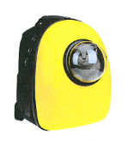 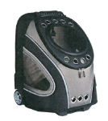 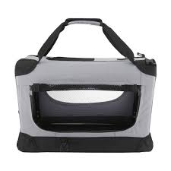 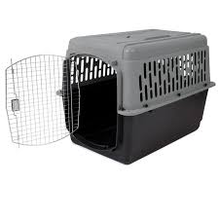 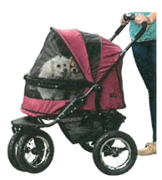 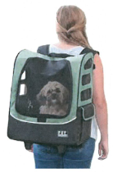

**Metropolitan trains**

Dogs that are restrained by a lead or harness, are muzzled and under the control of their owner always are permitted on metropolitan trains and public transport premises.

No other large animals are permitted.

Owners must clean up any mess created by their animals.

V/Line trains

Small animals (including cats and dogs) are permitted to travel on all V/Line train services in a suitable container (as above).

You can put your animal container in the luggage van of locomotive-hauled trains or inside the passenger cabin or bike and luggage storage area of V/Locity and Sprinter railcars. V/Line conductors will confirm if there is enough space for small animals.

V/Line Coaches

Only guide dogs, hearing dogs, guide and hearing dogs in training, and animals identified by an Assistance Animal Pass, or an interstate assistance animal accreditation are permitted on these services.

**Regional town buses**

Animals in a suitable container are permitted.

**Metropolitan rail replacement bus** **services**

Only guide dogs, hearing dogs, guide and hearing dogs in training, and animals identified by an Assistance Animal Pass or an interstate assistance animal accreditation and animals in a suitable container are permitted on metropolitan rail replacement bus services.

**V/Line rail replacement bus/coach services**

Only guide dogs, hearing dogs, guide and hearing dogs in training, and animals identified by an Assistance Animal Pass, or an interstate assistance animal accreditation are permitted on V/Line rail replacement bus or coach services.

No other animals are permitted (even if in a suitable container).

## Assistance Animals

An Assistance Animal Pass allows the animal to travel free on all public transport services in Victoria. The handler must have a valid ticket.

Not all animals are assistance animals, even if they assist you in some way. Companion, therapy, and facility animals are not considered assistance animals. House training and general obedience aren’t enough to qualify your animal for an Assistance Animal Pass.

You can still travel with your pet, see ‘Travelling with your pet’ for more information.

An assistance animal is trained, like a Guide Dog, to help ease or manage the effects of a permanent disability or condition.

Types of assistance animals covered by the Assistance Animal Pass (usually dogs) include:

* mobility support animals that help people with physical disabilities who use wheelchairs or have difficulty moving
* medical alert animals that are trained to help their handlers before and during a medical emergency
* psychiatric service animals that are trained to help people with psychiatric disabilities such as Post-Traumatic Stress Disorder, anxiety and panic attacks.

When applying for an Assistance Animal Pass, you need to provide evidence on how your assistance animal has been trained to help manage your disability and that it meets required standards of hygiene and obedience.

Image results for assistance animals pass

1. Includes a 50% discount on the daily weekend cap.
2. Allows the customer to travel for free within two consecutive zones. For journeys crossing more than two consecutive zones, the fare for the entire journey is charged.
3. International students at participating higher education institutions can apply for an international Undergraduate Student Education pass (iUSE pass) myki card, which gives the student a year-long myki pass at the concession rate.
4. Department of Veterans’ Affairs Pensioner Concession Card holders only.