Department of Transport
Sample Public Transport Plan Guide (Regional Bus)

The following document can be used as guide or template when
creating your Public Transport Plan (PTP), with the option to
insert your relevant event information and submit to
Department of Transport (DoT) for approval.

Sections of the Sample PTP may not be relevant to all
events within Victoria, due to their Metropolitan or
Regional locations.

In cases where events do not impact on a mode of
transport, this section can be removed from your
submitted plan.

Contents
Public Transport Plan 3
1. Event Description 4
2. Event Venue and Location 4
3. Summary of public transport service impacts 5
4. Summary of concurrent public transport service occupations 5
5. Summary of concurrent events in Regional Victoria 5
6. Road Closure and Diversion Details 6
7. Changes to Traffic Conditions Details 6
8. Bus & Coach Service Changes 7
9. Event Day Communications 10

Public Transport Plan

Event Name
Event Date
Event Logo/ Imagery

- Event Description
This includes the name, type and purpose of the event.
Event start time
Event finish time
Estimated event attendance

- Event Venue and Location
This may be an indoor or outdoor venue, local park, or on road event.
Address of venue.
An Aerial Map or SEMS Event Map can be inserted, indicating the affected roads and public transport routes surrounding the venue. These can be taken from Google Maps, Near Maps or SEMS.
For Example:

SEMS Location Map of Sturt Street, Ballarat

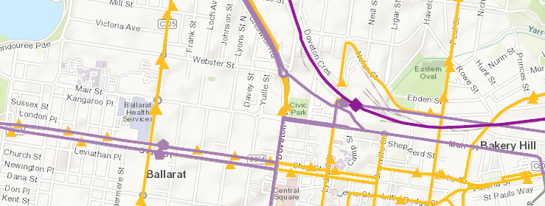

- Summary of public transport service impacts
Please complete this section either as you go, or at the end of organising your arrangements with the Public Transport Operator.
Bus & Coach Services
 | Diverted Services | Additional Services | Replacement Services | Additional Staff/ Management | Additional Communications
Bus | Yes/No | Yes/No | Yes/No | Yes/No | Yes/No
Coach | Yes/No | Yes/No | Yes/No | Yes/No | Yes/No

- Summary of concurrent public transport service occupations
Please complete this section either as you go, or at the end of organising your arrangements. This information will provide Department of Transport (DoT) and Public Transport Operators (PTO) with an insight into what external operations may impact on planning alternative transport arrangements. Advice can be received from the local PTO, Council or DoT.
Mode | Occupation/ s
Train (Regional) | Geelong Line Bus Replacement – Geelong to Southern Cross – All Day Saturday 15 & Sunday 16 August
Bus (Regional) | N/A
Road (Regional) | Sturt Street Ballarat, between Doveton & Lydiard Streets closed in both directions 16-18 August

- Summary of concurrent events in Regional Victoria
Please list any other concurrent events that may impact on your event or occurring within the same Region. This information will provide DoT and PTO’s with an insight into what external operations may impact on planning alternative transport arrangements. Advice can be received from the local Council or DoT.
Date | Event Name | Event Location | Start time | Finish time | Estimated Attendance
Fri 14 Aug | AFL Western Bulldogs v Geelong | Mars Stadium | 14:20 | 17:00 | 15,000
Sun 16 Aug | Ballarat Community Fun Run | Lake Wendouree | 12:00 | 17:00 | 20,000
*Concurrent event applies to those within the location/ region
- Road Closure and Diversion Details
Please indicate which transport mode will be affected by the below event road closures, including the nominated traffic diversion routes, as increased traffic congestion may affect public transport.

Bus Coach
Road/ Street Name | Section | Direction closed | Date Closed | Time Closed | Diversion Route
Sturt Street, Ballarat | Doveton to Lydiard Street | Eastbound | Sun 16 August | 06:00 to 20:00 | Doveton St - Mair St – Lydiard St
Sturt Street, Ballarat | Doveton to Lydiard Street | Westbound | Sun 16 August | 06:00 to 20:00 | Lydiard St - Mair St – Doveton St

- Changes to Traffic Conditions Details
Will there be changes to speed limits set up and approved by the Roads team? List the roads and corresponding changes to speed restrictions. Information on changes to traffic conditions must be communicated to on road bus and coach operators.
Road | Section | Normal speed | Altered speed | Date | Time
Sturt Street, Ballarat | Dawson Street N to Doveton Street | 60 kmph | 40 kmph | Sun 16 Aug | 6:00 to 20:00
Sturt Street, Ballarat | Armstrong Street S to Lydiard Street | 60 kmph | 40 kmph | Sun 16 Aug | 6:00 to 20:00
In the instance where there is an existing Traffic Management Plan which includes this information, please indicate whether this document is attached to support this section of the plan
- Bus & Coach Service Changes

Service Changes
Please indicate how Regional Bus and Coach services will be impacted and managed as a result of the event, including the nominated block & hold, bus replacement and/ or diversion details, as increased congestion may also affect the public transport network. Please include details of any bus stop closures, temporary bus stops or additional bus shuttle arrangements. This includes Night Network Services.

Details of the service changes can be included as per the below description, or in table format.
For example:

Description:
Sunday 16 August
From 6:00 until 20:00, Bus Routes 11 and 12 in Ballarat will be impacted by the Ballarat Cycling Race on Sturt Street, between Doveton and Lydiard Streets. Eastbound Services will be diverted and travel via Mair Street. Westbound Services will be diverted and travel via Dana Street.
The following bus stops will not be serviced on Sunday 16 August, and require a Customer Bulletin and Bag:
- Central Square SC/Sturt St (Ballarat Central) ID 35118
- Armstrong St/Sturt St (Ballarat Central) ID 35034
The following temporary bus stops will be required on Sunday 16 August:
Street Address | Cross Street | Date
(Approx. 301) Dana St | Armstrong St South (South Side) | 16 August
(Approx. 501) Dana St | Dawson St South (South Side) | 16 August
(Approx. 614) Mair St | Raglan St North (North Side) | 16 August
(Approx. 402) Mair St | Doveton St North (North Side) | 16 August

Table:

Route No. | Route Description | Road Closure | Diversion Route | Diversion Time | Stop Closures
11 | Ballarat Station – Wendouree Station via Howitt St | Sturt Street between Doveton and Lydiard Streets | Eastbound via Mair Street  Westbound via Dana Street | 6:00 to 20:00 | - Central Square SC/Sturt St (Ballarat Central) ID 35118  - Armstrong St/Sturt St (Ballarat Central) ID 35034
12 | Ballarat Station – Wendouree Station via Forest St

Temporary Bus Stops Required
Street Address | Cross Street | Date
(Approx. 301) Dana St | Armstrong St South (South Side) | 16 August
(Approx. 501) Dana St | Dawson St South (South Side) | 16 August
(Approx. 614) Mair St | Raglan St North (North Side) | 16 August
(Approx. 402) Mair St | Doveton St North (North Side) | 16 August

Summary of Additional Services
Some large events may require additional bus services, due to their location and event requirements. Please include any details regarding the additional services and stops required, particularly in the instance where services operate along an existing public route.
Additional bus services for events must be paid for by event organisers, as part of the overall event costs. The Department of Transport does not have any funding for this purpose. In the instance where event organisers require advice or assistance with additional bus planning, DoT can provide this where possible. Please contact our Special Events team for further advice at:
event.notification@ptv.vic.gov.au

Bus Route and Stop Information
Please include details of the affected Bus Stops including their Stop ID’s, which can be identified in SEMS using the Map and Information tools. Regional Bus Routes can be identified in SEMS by the Orange Lines, and Bus Stops by the Orange Triangles. Regional Coach Routes can be identified in SEMS by Light Purple Lines, and Coach Stops by the Light Purple Hectogons.
Using the information tool provided, you can select a Line or Triangle to identify their description, and then List affected bus stops and any replacement temporary bus stop locations.
Describe arrangements in place for any additional staff to manage the temporary bus stops.
Bus Route and Stop Coach Route and Stop
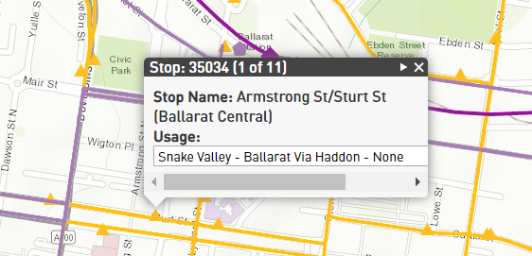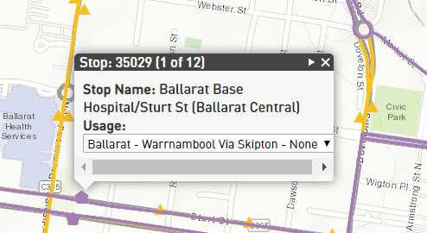

Staffing
Please include any arrangement for additional staffing to assist with operations during your event.
In the instance where there is an existing Traffic Management Plan which outline’s crowd management treatments, barriers, staff etc, please indicate whether this document is attached to support this section of the plan.

Communications
Customer Bulletins are required for each affected bus stop when services cannot access a specific bus stop. Customer Bulletins assist customers with information regarding the details of when the stop will close and reopen, and where their nearest bus stop is to access services. Confirmation of bus stops that require a Customer Bulletin are required, and whether the stop is also required to be closed or ‘bagged’ if the closure will occur all day.
If a bus stop requires bagging, the DoT carries this out via an external contractor prior to and post event and may require access to road closures to carry this out. Alternatively, an arrangement for the event organiser or local bus operator to post the customer bulletins can be formed, once copies of the customer bulletin are drafted by DoT and sent to the relevant stakeholder.

Example of a DoT Customer Bulletin:

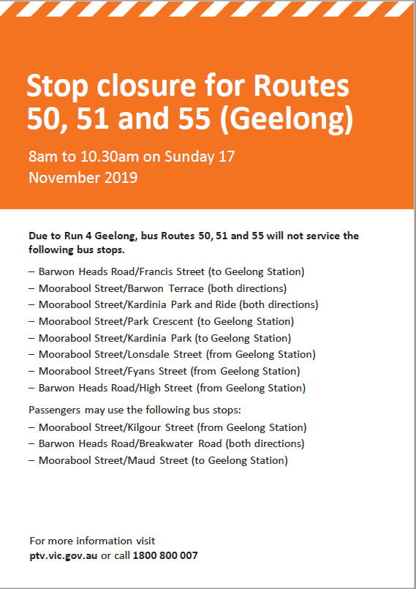

Information regarding the service changes will also be advertised via the Public Transport Operator and Public Transport Victoria (DoT) website.

Regional Town Network Maps
https://www.ptv.vic.gov.au/more/maps/regional-town-network-maps/

Regional Coach Night Network Map
https://www.ptv.vic.gov.au/assets/PDFs/Maps/Night-Network-maps/d8539d780b/PTV_NightCoach_map_2016.pdf

- Event Day Communications

Please include the following details;

- Location of Event Operations Centre (EOC)
- Operating hours of EOC
- Contact numbers for Event Day staff
- Contact names and numbers for public transport staff managing services on event day

